EXPERIMENT NO. 16
TITLE: IMPLEMENTATION OF SOBEL ALGORITHM USING OPENCV
PROGRAM:
import cv2

# Read the input image
img = cv2.imread("sobel_input.png")

if img is None:
print("Image not found! Check the image name.")
else:
# Convert the image to grayscale
gray = cv2.cvtColor(img, cv2.COLOR_BGR2GRAY)

# Apply Sobel filter in X direction
sobel_x = cv2.Sobel(gray, cv2.CV_64F, 1, 0, ksize=3)

# Apply Sobel filter in Y direction
sobel_y = cv2.Sobel(gray, cv2.CV_64F, 0, 1, ksize=3)

# Convert results into displayable images
sobel_x = cv2.convertScaleAbs(sobel_x)
sobel_y = cv2.convertScaleAbs(sobel_y)

# Combine X and Y results
sobel_combined = cv2.addWeighted(
sobel_x, 0.5, sobel_y, 0.5, 0
)

# Display all images
cv2.imshow("Original Image", img)
cv2.imshow("Sobel X Filter", sobel_x)
cv2.imshow("Sobel Y Filter", sobel_y)
cv2.imshow("Sobel Combined Filter", sobel_combined)

# Save output images
cv2.imwrite("sobel_x.png", sobel_x)
cv2.imwrite("sobel_y.png", sobel_y)
cv2.imwrite("sobel_combined.png", sobel_combined)

print("Sobel filtering completed successfully!")
cv2.waitKey(0)
cv2.destroyAllWindows()
COMMANDS USED:
cd Desktop
cd opencv
python experiment16_sobel.py

OUTPUT:
The original input image and three filtered images were displayed.
- Original Image: Displays the input image before filtering.
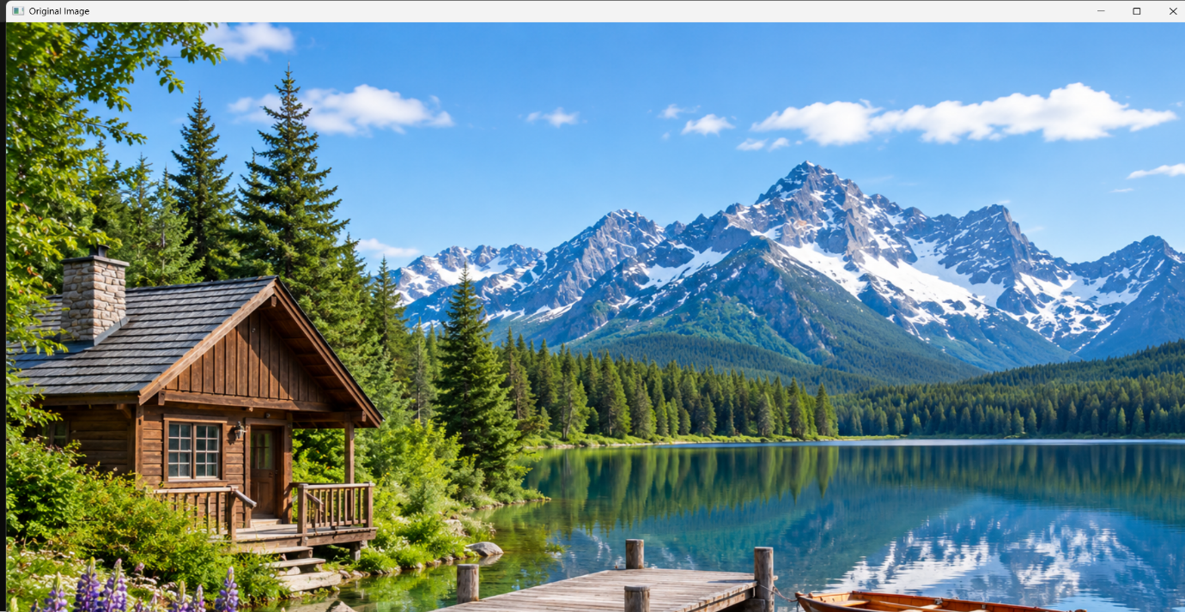
- Sobel X Filter: Highlights edges based on intensity changes in the horizontal direction.
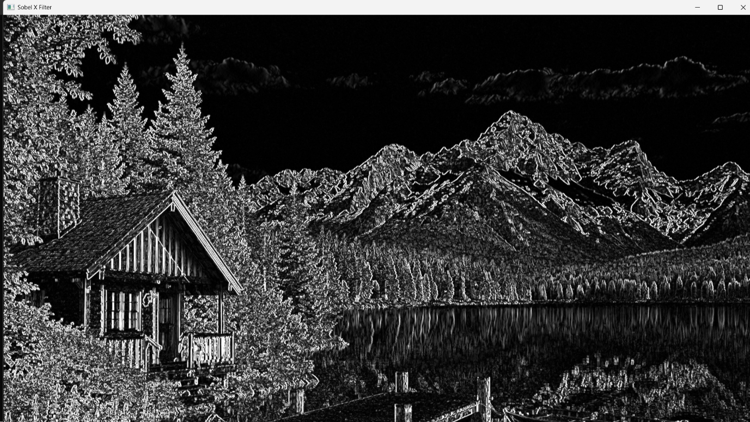

- Sobel Y Filter: Highlights edges based on intensity changes in the vertical direction.
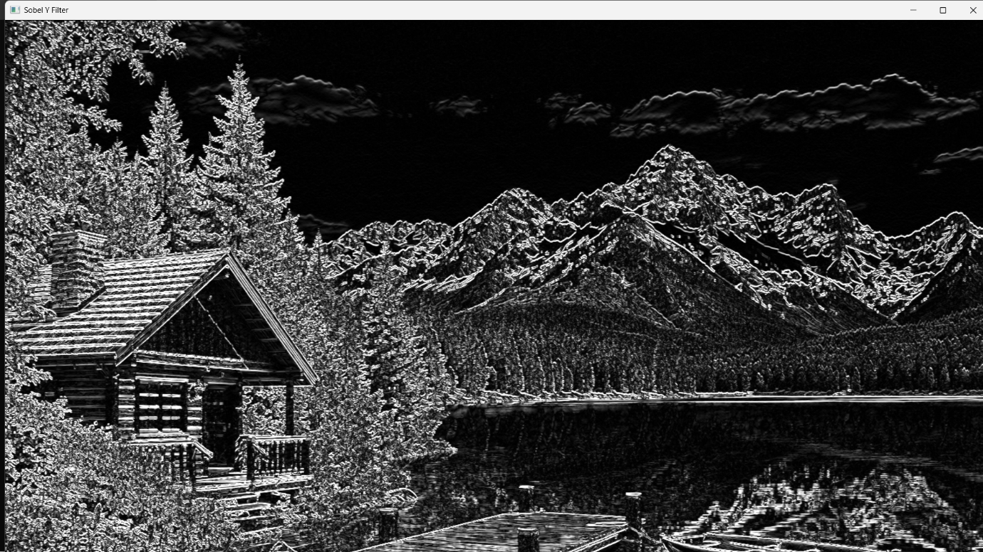

- Sobel Combined Filter: Combines the X and Y results to show edges in both directions.
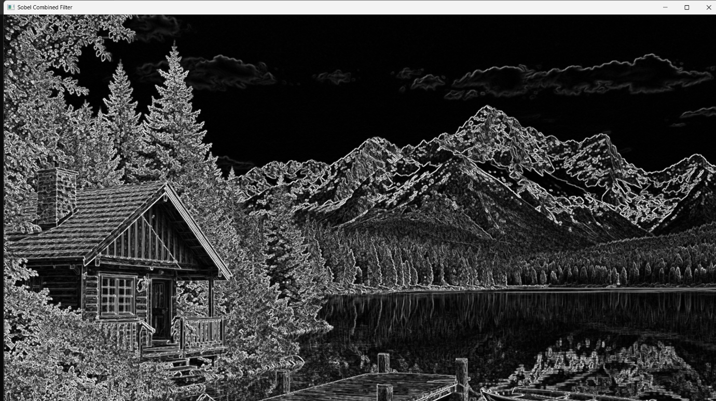

The output images are saved as sobel_x.png, sobel_y.png, and sobel_combined.png.
RESULT:
The Sobel algorithm was successfully executed using OpenCV, and the edge-filtered images were generated and saved.

